The user requires Windows OS

The user requires a 64 bit computer

The user requires Python 3.9.6

<https://www.python.org/downloads/release/python-396/>

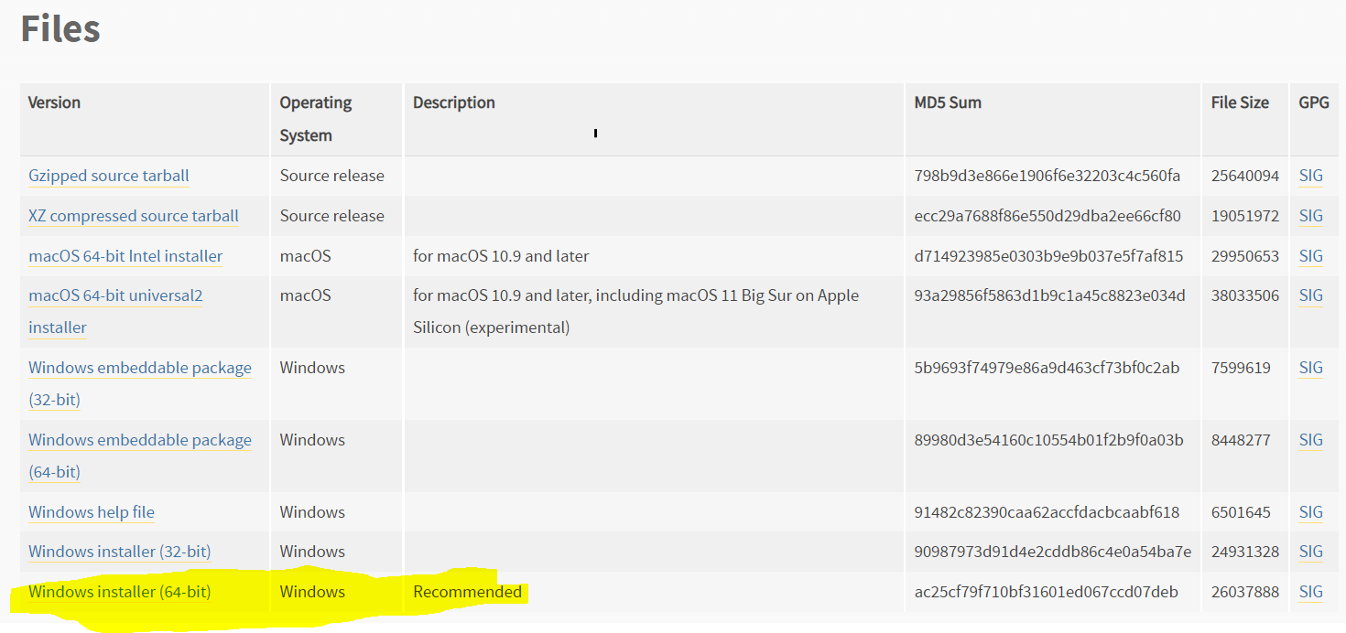

When the python installer runs, Check: ‘Add to PATH’ !!

Now Open Command Prompt

Type: ‘pip install pandas==1.3.1’ and press enter

Type: ‘pip install datetime==4.3’ and press enter

Type: ‘pip install openpyxl==3.0.7’ and press enter

Type: ‘pip install matplotlib==3.4.3’ and press enter

Type: ‘pip install numpy==1.21.1’ and press enter

Now Open Excel

(Go to file>Account) The user requires Excel 2019

(Go to File>Options>Trust Center>Trust Center Settings>Macro Settings):

Check: 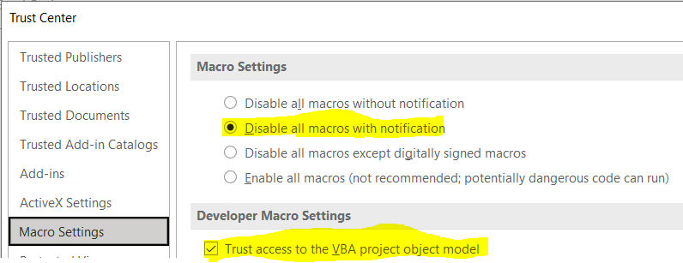

(Go to File>Options>Trust Center>Trust Center Settings>Trusted Locations):

Check: 

Click Add new location, add these two paths, type the description.

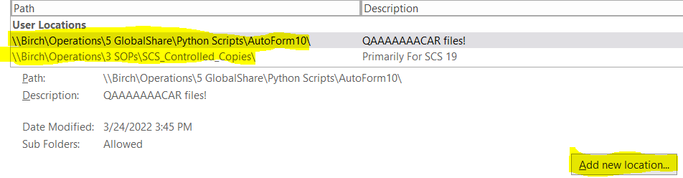

(For SCS 19 choose a different location like Desktop or My Documents. The folder in the example is not used anymore)

(In Excel Options, go to ‘Customize Ribbon’) Check ‘Developer’

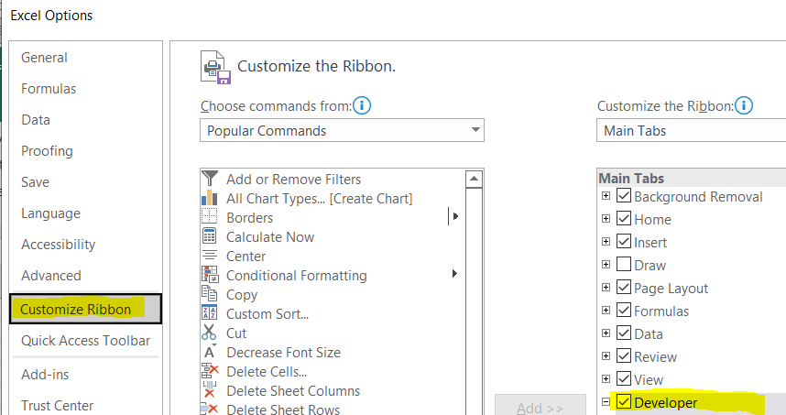

(Close out the excel file.)

**(Skip this section)**

**##############################################**

(Go to \\Birch\Operations\5 GlobalShare\Python Scripts\AutoForm10\QACAR)

(Right-click: SCS 29.02 QACAR_Master_Template.xlsm, Go to Properties, uncheck Read-Only, click Apply)

(Now open SCS 29.02 QACAR_Master_Template.xlsm)

(Go to Developer tab, click Visual Basic)

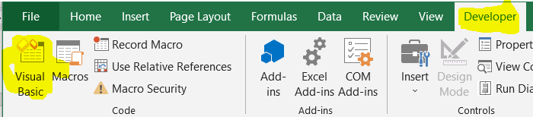

(The visual basic window should open, on the left side, click the ‘+’ next to ‘SCS 29.02 QACAR…..’)

(Enter the VBA Password (Ask Ross or James))

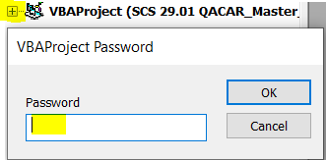

(Click Tools>References)

(Uncheck ‘MISSING:xlwings reference’)

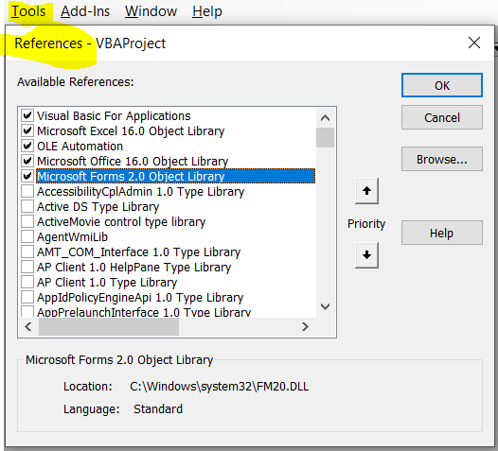

(Exit, Save the Excel File, And Apply Read-Only Status to SCS 29.02)

###################################################

Make sure the user has Read, Write, Modify rights on (\\birch\operations\QACAR)

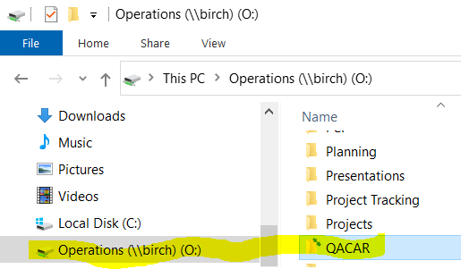

(Open the user’s Norton)

(Find a way to allow Excel scripts)

The user requires the teracopy 3.9 files

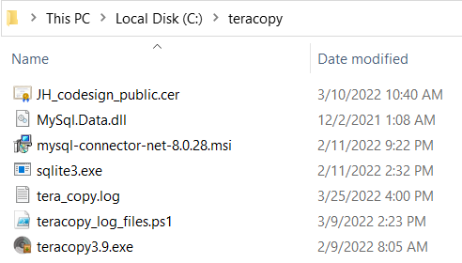

Done!